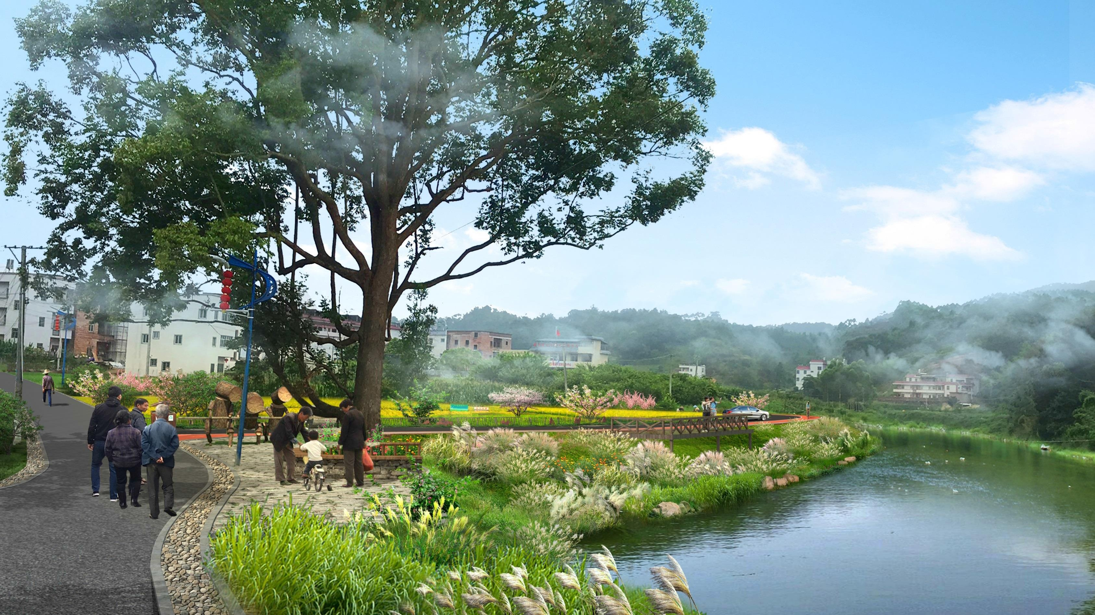

# *p*

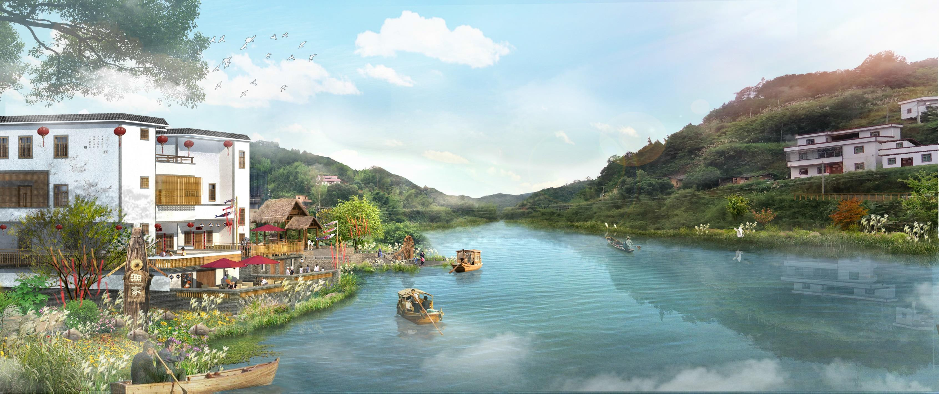

*p*

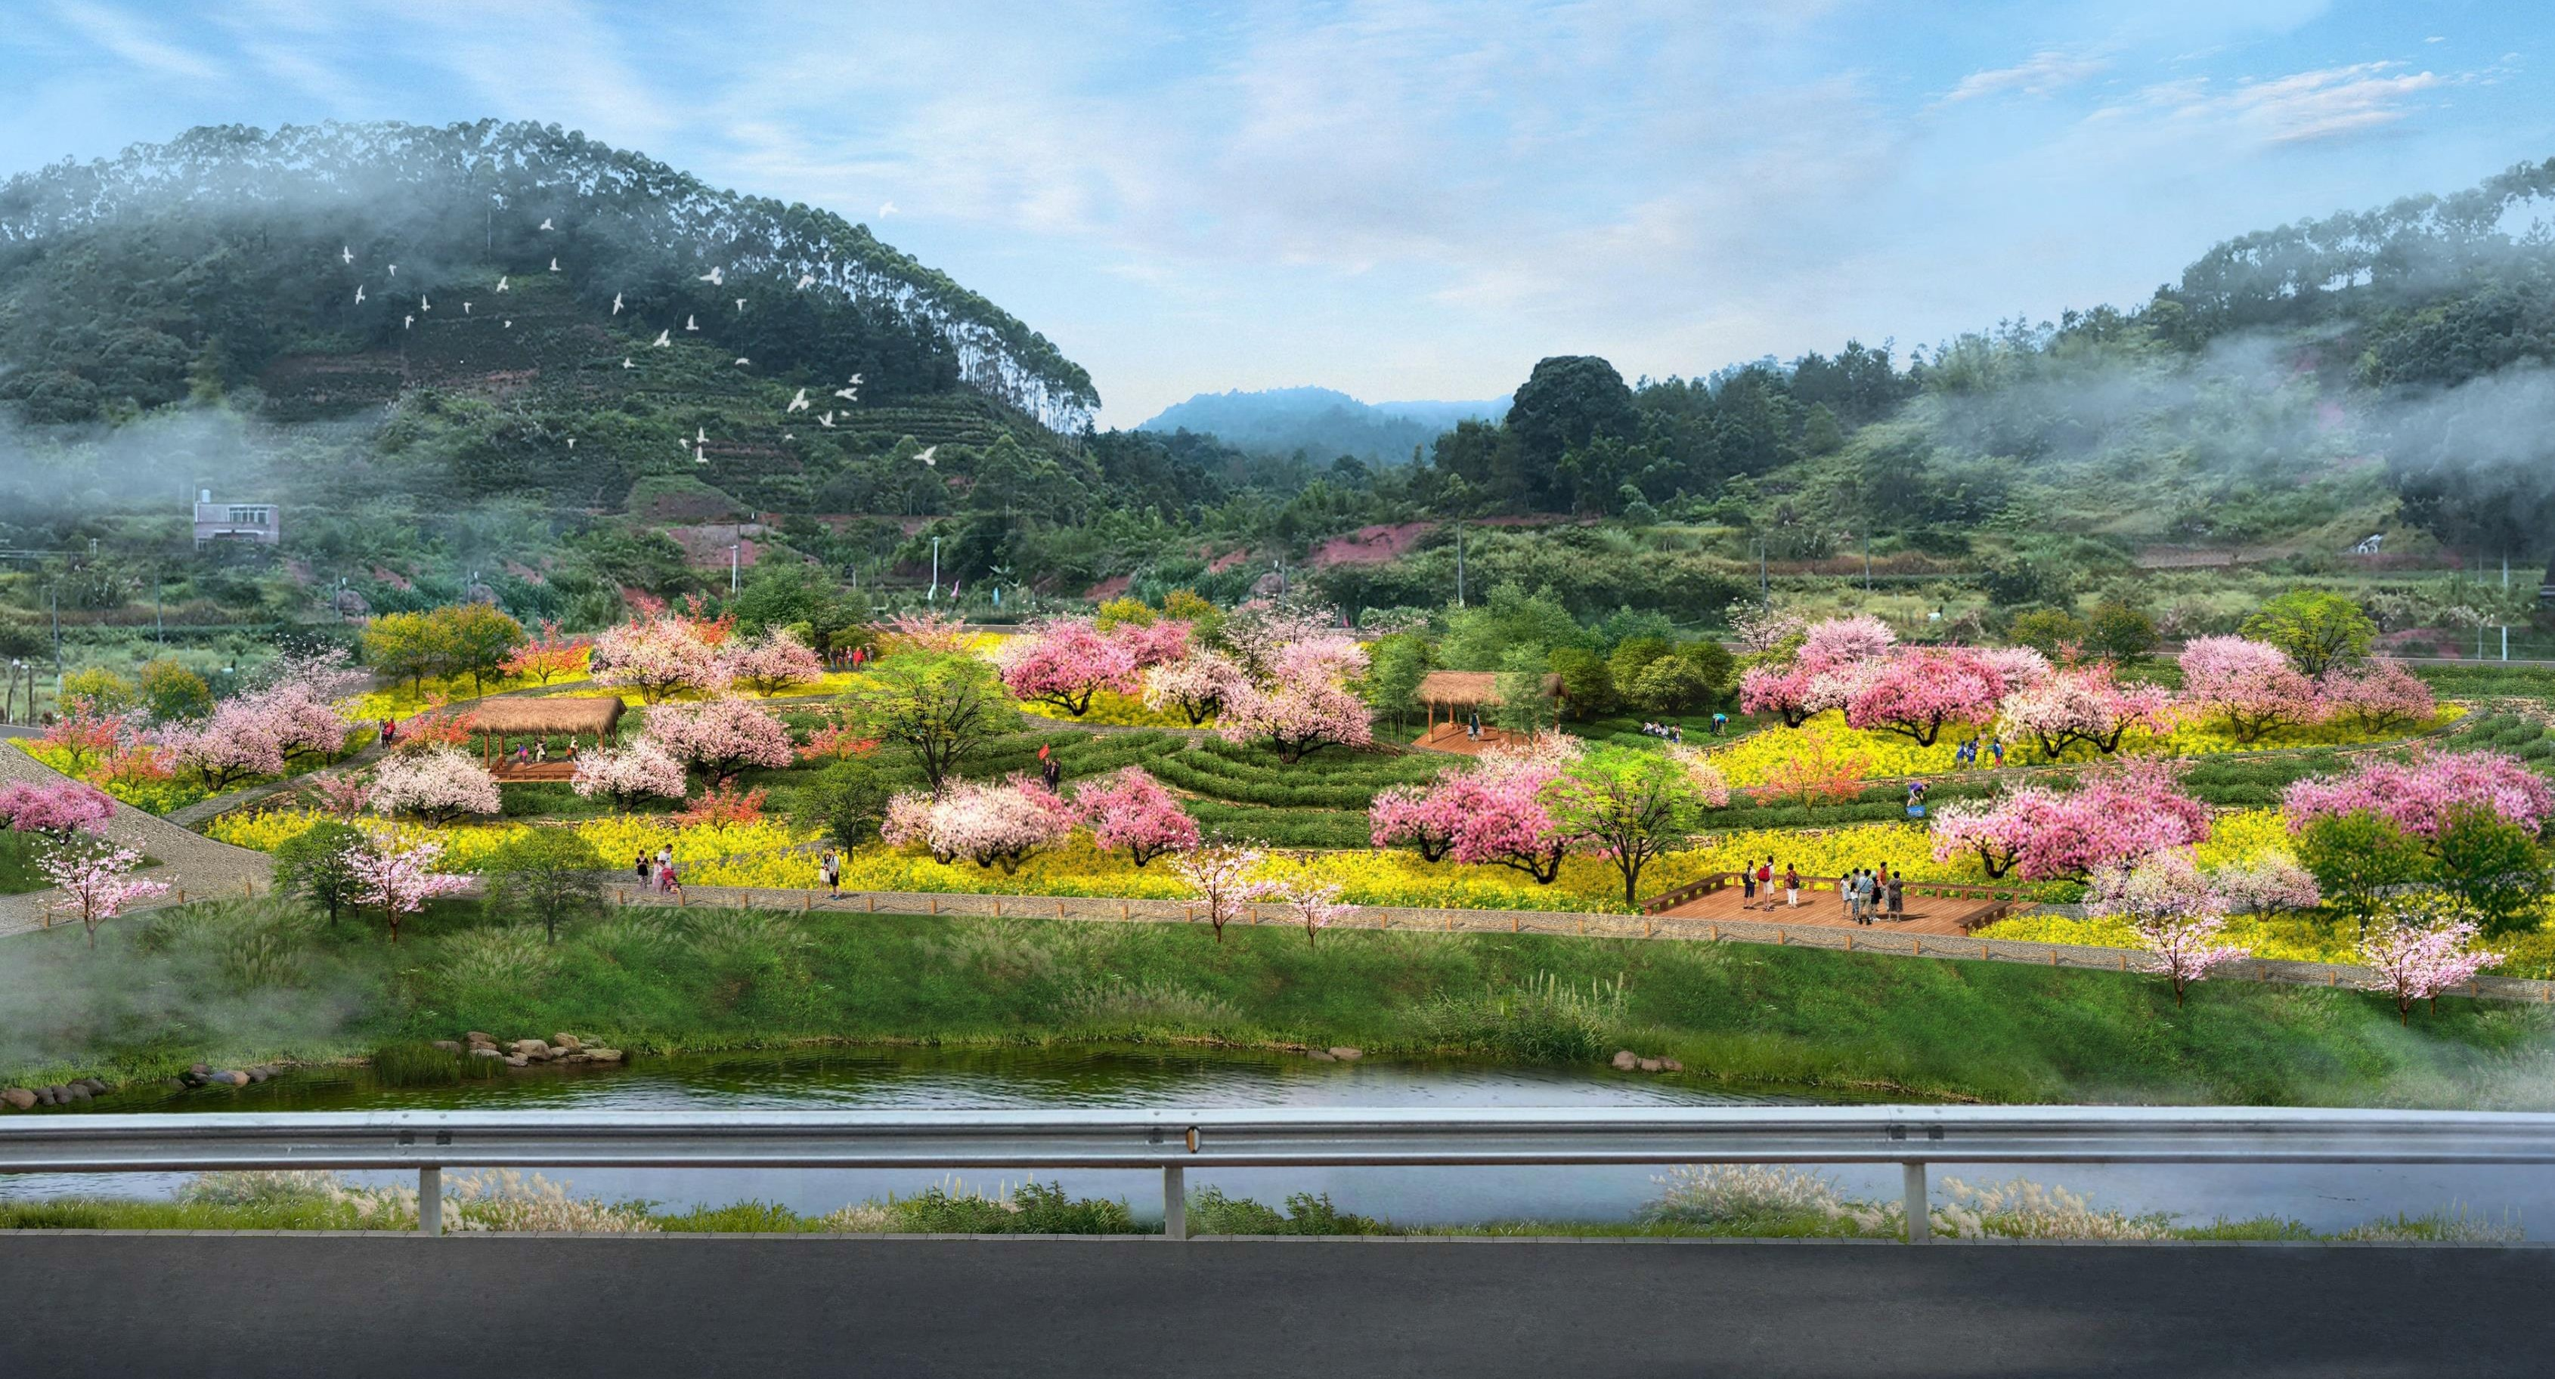

|  |  |
| --- | --- |
|  |  |
|  |  |

*p*

效果图

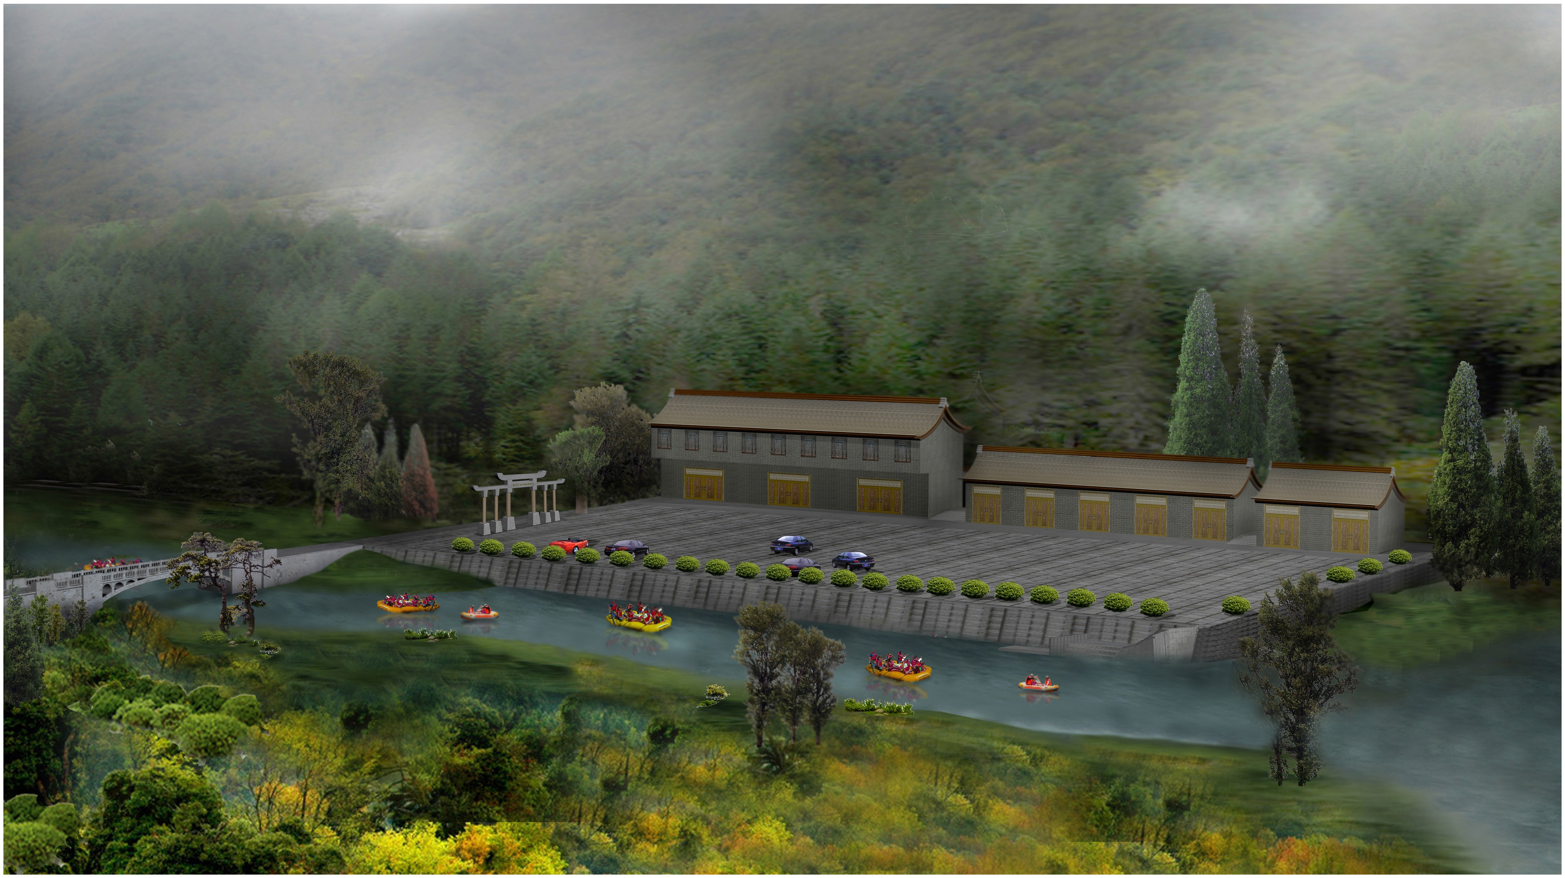

Design Scheme of Landscape Nodes for Three Villages IaingcunT own

